**V osmisměrce najdi 9 školních potřeb:**

**1**

**2**

**3**

**4**

**5**

**6**

**7**

**8**

**9**

|  |  |  |  |  |  |  |  |  |  |
| --- | --- | --- | --- | --- | --- | --- | --- | --- | --- |
| **S** | **H** | **A** | **R** | **P** | **E** | **N** | **E** | **R** | **A** |
| **C** | **E** | **G** | **A** | **D** | **E** | **S** | **K** | **R** | **D** |
| **I** | **D** | **L** | **O** | **K** | **S** | **Y** | **P** | **U** | **E** |
| **S** | **S** | **U** | **P** | **R** | **I** | **P** | **S** | **L** | **R** |
| **S** | **O** | **E** | **R** | **A** | **S** | **E** | **R** | **E** | **A** |
| **O** | **D** | **N** | **V** | **S** | **O** | **N** | **A** | **R** | **S** |
| **R** | **E** | **A** | **B** | **E** | **B** | **O** | **O** | **K** | **L** |
| **S** | **C** | **R** | **A** | **Y** | **O** | **N** | **K** | **E** | **R** |

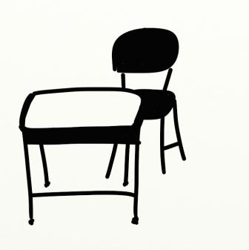

**5**

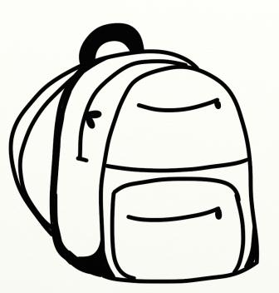

**2**

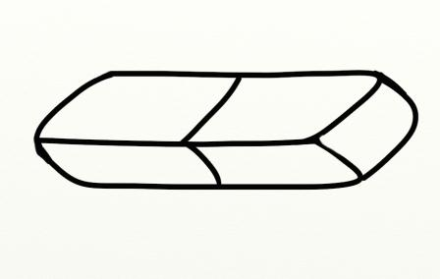

**1**

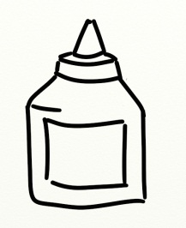

**13**

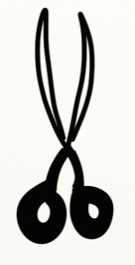

**9**

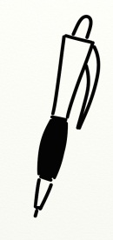

**10**

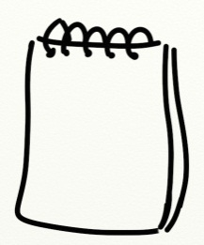

**4**

**__ DESK**

**__ PENCIL**

**__ RUBBER**

**__ SCHOOL BAG**

**_14_ EXERCISE BOOK**

**_4_ NOTEBOOK**

**_11_ SHARPENER**

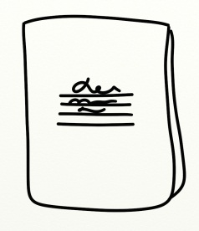

**14**

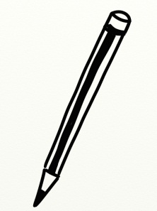

**12**

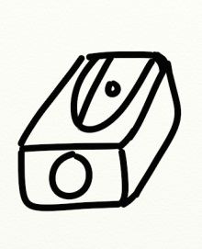

**11**

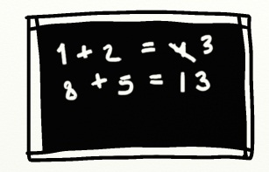

**8**

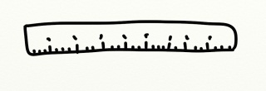

**3**

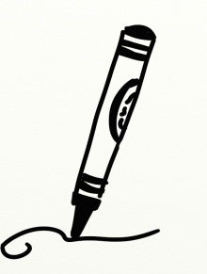

**7**

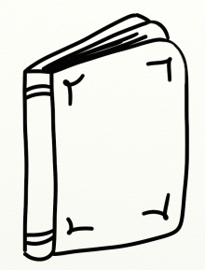

**6**

1. **Spoj slovíčka s obrázky:**

**SCHOOL THINGS**

**RULER __**

**BOOK __**

**PEN __**

**GLUE __**

**BOARD __**

**CRAYON _7_**

**SCISSORS __**